Mikaela Scheff

**Database of Magic: The Gathering Cards**

Magic: The Gathering is a trading card game that has been printed by Wizards of the Coast since 1993. There are currently over 13,000 unique cards and new sets of up to 400 cards (including reprinted cards) and released multiple times a year. The game is played between two or more people, each of whom has a deck of cards. There are two basic types of cards in Magic: land cards and spell cards. Land cards are free to play and are used to make resources. A player must spent resources to play spell cards. Every spell card has its cost written in symbols in the upper right hand corner.

The basic idea of the game is that each person is a wizard who battles their opponents by casting spells (playing spell cards).

Cards come in 6 colors: white, blue, black, red, green, and colorless (no color). A card can be colorless, one color, or multiple colors (a card cannot be both colorless and another color). There are 7 types of resources that are used to play spell cards: white, blue, black, red, green, generic, and colorless (a generic cost means that any resource type can be used while a colorless cost means that a colorless resource has to be used). The color of most cards is the same as the colors of resources needed to play the card. Land cards are always colorless.

Every card has at least one type: land, artifact, creature, instant, planeswalker, sorcery, or enchantment. A card can have multiple types. A card may also have a supertype and/or a subtype.

In my database, I included only attributes that every card has. Because of this, I did not include subtypes or supertypes and I did not include cards that have more than one type.

My idea for the database is that a player could use it to search for cards that would be good in their deck. I picked a limited selection of cards to include in my database.

I created three webpages to allow players to search for cards and one that they can use to add a land card. All four of these webpages can be accessed from the directory I put together: <http://web.simmons.edu/~scheffm/mtgLinks.html>. Since there are quite a lot of different ways a player may wish to search for cards, I decided to make forms (and stored procedures) for three that I thought would be most useful. Using my webpages, a player can find the names of all cards with a specific color and type combination, information about all cards containing a specific string of characters in their name, and information about all cards of a specific type.

**Creating and Populating Tables**

**“Fixed” Tables:**

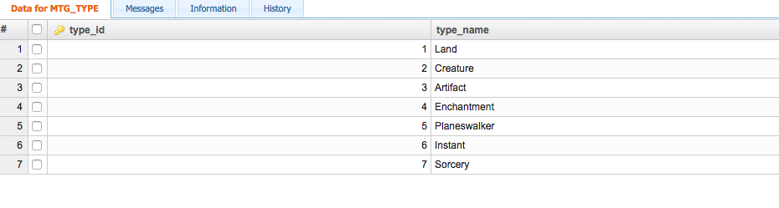

create table MTG_TYPE(type_id Integer NOT NULL AUTO_INCREMENT, type_name char(100) NOT NULL, CONSTRAINT type_pkPRIMARY KEY (type_id))

insert into MTG_TYPE

  values(1,"Land");

insert into MTG_TYPE

  values(2,"Creature");

insert into MTG_TYPE

  values(3,"Artifact");

insert into MTG_TYPE

  values(4,"Enchantment");

insert into MTG_TYPE

  values(5,"Planeswalker");

insert into MTG_TYPE

  values(6,"Instant");

insert into MTG_TYPE

  values(7,"Sorcery”);

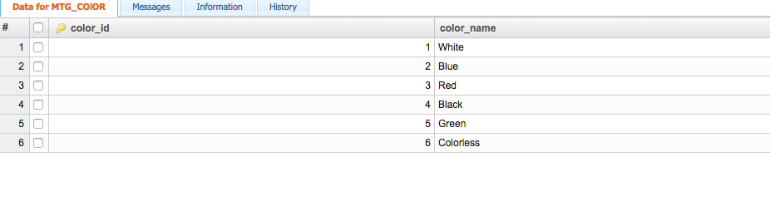create table MTG_COlOR(color_id Integer NOT NULL AUTO_INCREMENT, color_name char(100) NOT NULL, CONSTRAINTcolor_pk PRIMARY KEY (color_id))

insert into MTG_COlOR

  values(2,"Blue");

insert into MTG_COlOR

  values(3,"Red");

insert into MTG_COlOR

  values(4,"Black");

insert into MTG_COlOR

  values(5,"Green");

insert into MTG_COlOR

  values(6,"Colorless");

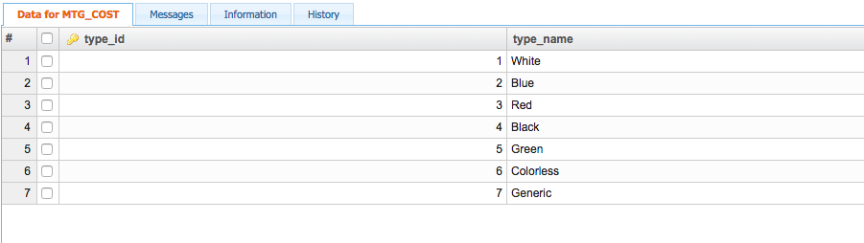

create table MTG_COST(type_id Integer NOT NULL AUTO_INCREMENT, type_name char(100) NOT NULL, CONSTRAINT type_pkPRIMARY KEY (type_id))

insert into MTG_COST

  values(1,"White");

insert into MTG_COST

  values(2,"Blue");

insert into MTG_COST

  values(3,"Red");

insert into MTG_COST

  values(4,"Black");

insert into MTG_COST

  values(5,"Green");

insert into MTG_COST

  values(6,"Colorless");

insert into MTG_COST

  values(7,"Generic”);

**Tables for inserting cards:**

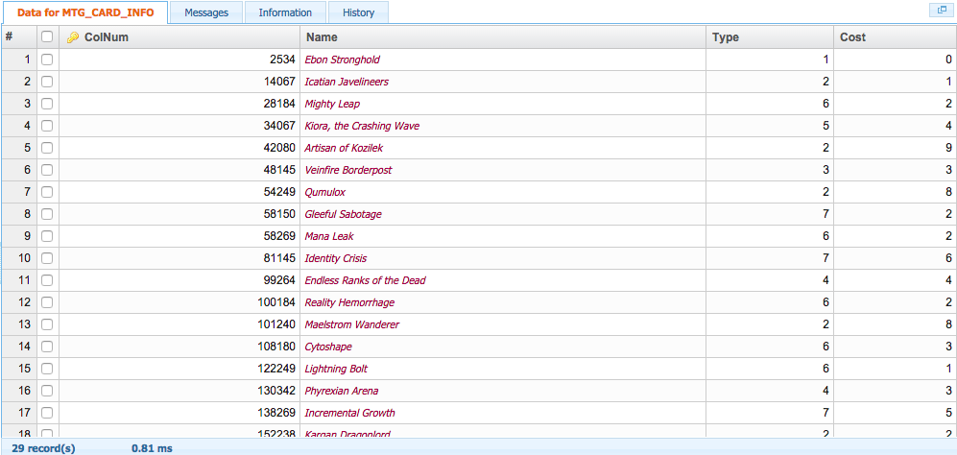

create table MTG_CARD_INFO(ColNum Integer NOT NULL, Name char(100) NOT NULL, Type Integer NOT NULL, Cost IntegerNOT NULL, CONSTRAINT info_pk PRIMARY KEY (ColNum))

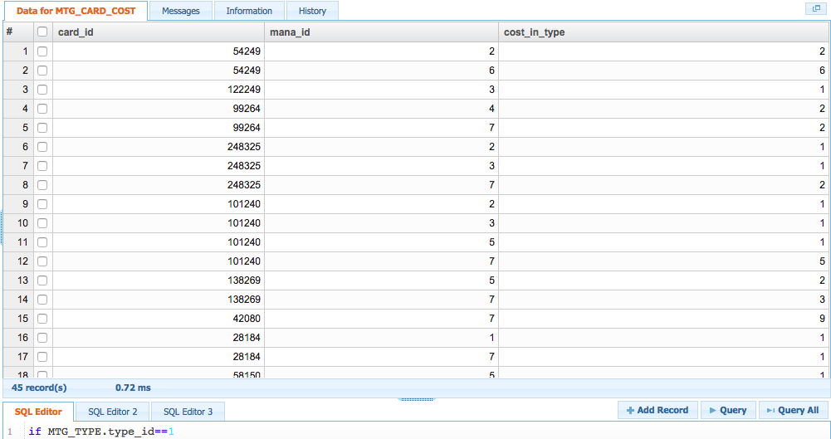

create table MTG_CARD_COST(card_id Integer NOT NULL, mana_id Integer NOT NULL, cost_in_type Integer NOT NULL,

  CONSTRAINT fk_card_combo2

  FOREIGN KEY (card_id)

    REFERENCES MTG_CARD_INFO(ColNum)

    ON DELETE CASCADE,

  CONSTRAINT fk_cost_combo

  FOREIGN KEY (mana_id)

    REFERENCES MTG_COST(type_id)

    ON DELETE CASCADE

)

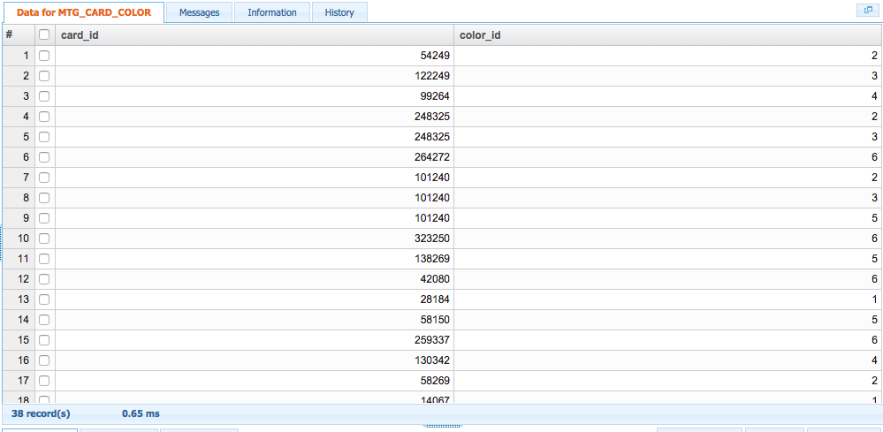

create table MTG_CARD_COLOR(card_id Integer NOT NULL, color_id Integer NOT NULL, CONSTRAINT fk_card_combo

  FOREIGN KEY (card_id)

    REFERENCES MTG_CARD_INFO(ColNum)

    ON DELETE CASCADE,

  CONSTRAINT fk_color_combo

  FOREIGN KEY (color_id)

    REFERENCES MTG_COlOR(color_id)

    ON DELETE CASCADE

)

**Populating the database with cards:**

insert into MTG_CARD_INFO

  values(054249,"Qumulox",2,8);

insert into MTG_CARD_COST

  values(054249,2,2);

insert into MTG_CARD_COST

  values(054249,6,6);

insert into MTG_CARD_COLOR

  values(054249,2);

insert into MTG_CARD_INFO

  values(122249,"Lightning Bolt",6,1);

insert into MTG_CARD_COST

  values(122249,3,1);

insert into MTG_CARD_COLOR

  values(122249,3);

insert into MTG_CARD_INFO

  values(099264,"Endless Ranks of the Dead",4,4);

insert into MTG_CARD_COST

  values(099264,4,2);

insert into MTG_CARD_COST

  values(099264,7,2);

insert into MTG_CARD_COLOR

  values(099264,4);

insert into MTG_CARD_INFO

  values(248325,"Dack's Duplicate",2,4);

insert into MTG_CARD_COST

  values(248325,2,1);

insert into MTG_CARD_COST

  values(248325,3,1);

insert into MTG_CARD_COST

  values(248325,7,2);

insert into MTG_CARD_COLOR

  values(248325,2);

insert into MTG_CARD_COLOR

  values(248325,3);

insert into MTG_CARD_INFO

  values(264272,"Swamp",1,0);

insert into MTG_CARD_COLOR

  values(264272,6);

insert into MTG_CARD_INFO

  values(101240,"Maelstrom Wanderer",2,8);

insert into MTG_CARD_COST

  values(101240,2,1);

insert into MTG_CARD_COST

  values(101240,3,1);

insert into MTG_CARD_COST

  values(101240,5,1);

insert into MTG_CARD_COST

  values(101240,7,5);

insert into MTG_CARD_COLOR

  values(101240,2);

insert into MTG_CARD_COLOR

  values(101240,3);

insert into MTG_CARD_COLOR

  values(101240,5);

insert into MTG_CARD_INFO

  values(323250,"Coastal Tower",1,0);

insert into MTG_CARD_COLOR

  values(323250,6);

insert into MTG_CARD_INFO

  values(138269,"Incremental Growth",7,5);

insert into MTG_CARD_COST

  values(138269,5,2);

insert into MTG_CARD_COST

  values(138269,7,3);

insert into MTG_CARD_COLOR

  values(138269,5);

insert into MTG_CARD_INFO

  values(042080,"Artisan of Kozilek",2,9);

insert into MTG_CARD_COST

  values(042080,7,9);

insert into MTG_CARD_COLOR

  values(042080,6);

insert into MTG_CARD_INFO

  values(028184,"Mighty Leap",6,2);

insert into MTG_CARD_COST

  values(028184,1,1);

insert into MTG_CARD_COST

  values(028184,7,1);

insert into MTG_CARD_COLOR

  values(028184,1);

insert into MTG_CARD_INFO

  values(058150,"Gleeful Sabotage",7,2);

insert into MTG_CARD_COST

  values(058150,5,1);

insert into MTG_CARD_COST

  values(058150,7,1);

insert into MTG_CARD_COLOR

  values(058150,5);

insert into MTG_CARD_INFO

  values(259337,"Panic Spellbomb",3,1);

insert into MTG_CARD_COST

  values(259337,7,1);

insert into MTG_CARD_COLOR

  values(259337,6);

insert into MTG_CARD_INFO

  values(130342,"Phyrexian Arena",4,3);

insert into MTG_CARD_COST

  values(130342,4,2);

insert into MTG_CARD_COST

  values(130342,7,1);

insert into MTG_CARD_COLOR

  values(130342,4);

insert into MTG_CARD_INFO

  values(058269,"Mana Leak",6,2);

insert into MTG_CARD_COST

  values(058269,2,2);

insert into MTG_CARD_COST

  values(058269,7,1);

insert into MTG_CARD_COLOR

  values(058269,2);

insert into MTG_CARD_INFO

  values(014067,"Icatian Javelineers",2,1);

insert into MTG_CARD_COST

  values(014067,1,1);

insert into MTG_CARD_COLOR

  values(014067,1);

insert into MTG_CARD_INFO

  values(081145,"Identity Crisis",7,6);

insert into MTG_CARD_COST

  values(081145,1,2);

insert into MTG_CARD_COST

  values(081145,4,2);

insert into MTG_CARD_COST

  values(081145,7,2);

insert into MTG_CARD_COLOR

  values(081145,1);

insert into MTG_CARD_COLOR

  values(081145,4);

insert into MTG_CARD_INFO

  values(174244,"Diregraf Escort",2,1);

insert into MTG_CARD_COST

  values(174244,5,1);

insert into MTG_CARD_COLOR

  values(174244,5);

insert into MTG_CARD_INFO

  values(108180,"Cytoshape",6,3);

insert into MTG_CARD_COST

  values(108180,2,1);

insert into MTG_CARD_COST

  values(108180,5,1);

insert into MTG_CARD_COST

  values(108180,7,1);

insert into MTG_CARD_COLOR

  values(108180,2);

insert into MTG_CARD_COLOR

  values(108180,5);

insert into MTG_CARD_INFO

  values(210272,"Blazing Hellhound",2,4);

insert into MTG_CARD_COST

  values(210272,3,1);

insert into MTG_CARD_COST

  values(210272,4,1);

insert into MTG_CARD_COST

  values(210272,7,2);

insert into MTG_CARD_COLOR

  values(210272,3);

insert into MTG_CARD_COLOR

  values(210272,4);

insert into MTG_CARD_INFO

  values(048145,"Veinfire Borderpost",3,3);

insert into MTG_CARD_COST

  values(048145,3,1);

insert into MTG_CARD_COST

  values(048145,4,1);

insert into MTG_CARD_COST

  values(048145,7,1);

insert into MTG_CARD_COLOR

  values(048145,3);

insert into MTG_CARD_COLOR

  values(048145,4);

insert into MTG_CARD_INFO

  values(100184,"Reality Hemorrhage",6,2);

insert into MTG_CARD_COST

  values(100184,3,1);

insert into MTG_CARD_COST

  values(100184,7,1);

insert into MTG_CARD_COLOR

  values(100184,6);

insert into MTG_CARD_INFO

  values(152238,"Kargan Dragonlord",2,2);

insert into MTG_CARD_COST

  values(152238,3,2);

insert into MTG_CARD_COLOR

  values(152238,3);

insert into MTG_CARD_INFO

  values(194337,"Essence Warden",2,1);

insert into MTG_CARD_COST

  values(194337,5,1);

insert into MTG_CARD_COLOR

  values(194337,5);

insert into MTG_CARD_INFO

  values(034067,"Kiora, the Crashing Wave",5,4);

insert into MTG_CARD_COST

  values(034067,2,1);

insert into MTG_CARD_COST

  values(034067,5,1);

insert into MTG_CARD_COST

  values(034067,7,2);

insert into MTG_CARD_COLOR

  values(034067,2);

insert into MTG_CARD_COLOR

  values(034067,5);

**Stored Procedures**

**Get all cards of a color+type combo:**

CREATE PROCEDURE CardFromColorType(IN color CHAR(100), IN type CHAR(100))

SELECT Name

  FROM MTG_TYPE

  JOIN MTG_CARD_INFO

  ON type_id = MTG_CARD_INFO.type

  JOIN MTG_CARD_COLOR as c

  ON ColNum = card_id

  JOIN MTG_COlOR as b

  ON c.color_id = b.color_id

  WHERE color_name like color and type_name like type

  ORDER BY Name

CALL CardFromColorType(color,type)

**Find card info by part or full card name:**

CREATE PROCEDURE CardFromName(IN name CHAR(100))

SELECT MTG_CARD_INFO.ColNum, MTG_CARD_INFO.Name, color_name as color, MTG_TYPE.type_name as type, MTG_CARD_INFO.cost as CMC

  FROM MTG_TYPE

  JOIN MTG_CARD_INFO

  ON type_id = MTG_CARD_INFO.type

  JOIN MTG_CARD_COLOR as c

  ON ColNum = card_id

  JOIN MTG_COlOR as b

  ON c.color_id = b.color_id

  WHERE MTG_CARD_INFO.Name like CONCAT("%", name,"%")

  ORDER BY Name

CALL CardFromName(name)

**Find card info by card type:**

CREATE PROCEDURE CardFromType(IN type CHAR(100))

SELECT MTG_CARD_INFO.ColNum, MTG_CARD_INFO.Name, color_name as color, MTG_TYPE.type_name, MTG_CARD_INFO.cost as CMC

  FROM MTG_TYPE

  JOIN MTG_CARD_INFO

  ON type_id = MTG_CARD_INFO.type

  JOIN MTG_CARD_COLOR as c

  ON ColNum = card_id

  JOIN MTG_COlOR as b

  ON c.color_id = b.color_id

  WHERE MTG_TYPE.type_name like type

  ORDER BY Name

**Form Screenshots:**



